**Group Project, Phase 2 (Implementation, documentation, and presentation)**

**Hypertension: A Silent Killer and Its Implications**

**Uncovering Hidden Adverse Drug Reactions in Hypertensive Patients**

Group Members:

VARSHA SANE: EUID: vs1625

SAI SHIVANI PARIMI: EUID: sp3403

SUNITHA BYRAPAKA: EUID: sb3073

RIA SINGH: EUID: rs1711

SRAVANI PULMADI: EUID: sp3194

**Medical Condition: I10**

**Data Source: FDA’s FAERS**

**Number of Data Records: 428969**

**Introduction**

Blood pressure (BP) or hypertension (HT) is a significant cause of global morbidities and mortalities. It is also known by another nickname, the “silent killer," because it doesn’t show any outward sign, but causes great destruction to the body by resulting in life-threatening conditions such as heart disease, a stroke, and kidney failure. World Health Organization (WHO, 2023) states that hypertension is one of the leading causes of mortality in adults in an estimated 1.28 billion individuals, 46% of adults don't even know they have hypertension, and only 42% are diagnosed and treated.

**Causes and Risk Factors of Hypertension**

Hypertension is also categorized broadly between primary (essential) hypertension and secondary hypertension. The vast majority of the cases are categorized as primary (about 90–95%) and have no identifiable etiology. Genetic predisposition, age, and environment are the primary contributors (Whelton et al., 2018). Secondary hypertension, however, is secondary to another condition like kidney disease, an endocrine disease, or certain pills (Oparil et al., 2018). Hypertension results because there are countless of risk factors that consist of modifiable and non-modifiable factors. Age, genetics, and family history are the non-modifiable risk factors, while the modifiable risk factors include high salt intake, obesity, smoking, physical inactivity, and excessive alcohol consumption (Mills et al., 2020; Carey et al., 2018). The worldwide epidemiology of hypertension presents pessimistic views, where there are extremely high rates of undiagnosed and uncontrolled patients, especially in the developing world (Mills et al., 2020).

**Health Implications of Hypertension**

Untreated hypertension is severe and wide-ranging. Chronic high blood pressure may lead to heart disease, stroke, kidney disease, and dementia, among other health conditions (Oparil et al., 2018). In particular, cardiovascular diseases (CVD) are likely to be experienced by hypertensive patients, which remains a major cause of death across the world. More than 100 million adults in the United States have hypertension, but only approximately 46% of them have their condition under control (Fryar et al., 2017). Hypertension is also responsible for causing chronic kidney disease (CKD) by injuring the blood vessels within the kidneys and resulting in progressive loss of kidney function (Carey et al., 2018). High blood pressure management is central in preventing such complications and improving overall public health results.

**Management and Treatment of Hypertension**

Treatment of hypertension is via lifestyle alteration and pharmacology. Lowering alcohol consumption, physical exercise, smoking cessation, and diet all constitute hypertensive treatment (Carey et al., 2018). Amongst food-based treatments, the DASH diet has also been reported to reduce blood pressure significantly by its emphasis on fruit, vegetables, whole grains, lean meat, and low-fat milk (Appel et al., 2017). In addition, moderate physical activity, including aerobic exercise and strength training, may also regulate blood pressure and support cardiovascular health (Whelton et al., 2018). Pharmacologically, antihypertensive medications are also typically indicated to reduce blood pressure, such as diuretics, ACE inhibitors, beta-blockers, and calcium channel blockers (Muntner et al., 2020). The drug of choice normally depends on the individual characteristics of the patient, such as the level of hypertension and whether there is any other disease (Whelton et al., 2018).

**Factors Hindering the Successful Management of Hypertension**

Hypertension continues to be difficult to manage in practice, even though effective drugs are available, due to various factors. The principal barriers include poor treatment adherence, ignorance about the condition, and poor access to health services (Fryar et al., 2017). People with hypertension are often unaware of this condition because it is usually asymptomatic; others find it hard to adhere to their medication regimens (Muntner et al., 2020). Mills et al. (2020) discuss hypertension as a global challenge and maintain that awareness creation and improving access to care are necessary to mitigate the disease's burden. In the USA, for instance, public health efforts to create awareness about hypertension have significantly improved diagnosis and treatment rates (Fryar et al., 2017). In addition, telehealth and mobile health applications have proven beneficial in promoting adherence by providing continuous support and monitoring for patients (Oparil et al., 2018).

**Particular Reason for Choosing Hypertension**

Our group has decided to focus on hypertension because it plays a strong role in global health and can be utilized to improve patient outcomes through evidence-based programs. We are particularly interested, as a group, in the intersection of health informatics and predictive analytics. Integrating Electronic Health Records (EHRs) and machine learning algorithms has a high potential to identify high-risk individuals early, enabling healthcare workers to implement timely interventions and prevent complications (Muntner et al., 2020). We also recognize the potential of mobile health applications in facilitating behavior change by influencing patients to monitor their blood pressure on a regular basis and adhere to healthier lifestyles (Carey et al., 2018). Our motivation stems especially from the idea that evidence-based treatment protocols, derived from analysis of current health systems, have the ability to improve patient outcomes for people with hypertension.

**Research Questions**

1. Are certain hypertension drugs associated with a higher number of disproportionate adverse event signals compared to others?​
2. What are the most frequently reported adverse events with high PRR? Or What PTs (Preferred Terms) are disproportionately reported across multiple drugs?​
3. Which drug–event combinations have the highest PRR values?​
4. Are there any unexpected or underreported adverse events linked to antihypertensive drugs?
5. Do some antihypertensive drugs show co-occurring AEs suggestive of class-specific effects?
6. Can ARM reveal meaningful signals missed by PRR, and which warrant further investigation?

**Related Work**

The analysis of adverse drug reactions (ADRs) in hypertension patients has now attracted pharmacovigilance researchers to develop data-centric methods. The FAERS pharmacovigilance database hosts the two primary analytical approaches for identifying concealed safety warnings through the combination of Proportional Reporting Ratio (PRR) and Association Rule Mining (ARM).

Liu et al. (2024) extracted both established adverse drug reactions including hyperkalemia as well as rare occurrences of acute pancreatitis and rhabdomyolysis from FAERS and JADER databases through a PRR-based approach. According to Liu et al. (2024) PRR demonstrates powerful detection capability in identifying disproportionate adverse event reporting from clinical databases. A study by Ren et al. (2025) found cardiovascular drugs especially antihypertensive medications most frequently among the 50 drugs linked to orthostatic hypotension. The analysis techniques PRR and ROR demonstrate value for basic pharmacovigilance activities concerning blood pressure medications (Ren et al., 2025). The event-focused method used by PRR has led research teams to combine it with ARM to identify major drug-event relational patterns. Claim analysis using the ARM method shows Yamamoto et al. (2023) that large data systems reveal early warning signals to study drug-event connections in ways beyond basic statistics (Yamamoto et al., 2023). Zhou et al. (2024) used ARM to discover connections between hypertension following drug administration with rofecoxib and lenvatinib. The combined implementation of PRR and ARM as a dual signal-detection approach increases both the strength of detection and the clarity of clinical results (Zhou et al., 2024).

Our methodological design for analyzing antihypertensive medication adverse events uses PRR and ARM according to the findings from these studies. This modeling approach unifies drug safety signal development through categorical disproportionality statistics and multi-item association rules across different drug perspectives.

**Methods**

Examine of adverse drug events linked to hypertension medications was performed using FDA's FAERS dataset through dual-method analysis. Our analysis utilized Proportional Reporting Ratio (PRR) and Association Rule Mining (ARM) methods supported through comprehensive preprocessing and normalization processes.

**1. Data Preprocessing and Normalization**

* The hypertension_5771.csv dataset required relevant record filtering before pandas software cleaned it.
* **Text normalization** was applied: All drug names received lowercase formatting along with whitespace removal. Through the UMLS API and RXNORM source, standard terminology was implemented by converting drug names into UMLS Concept Unique Identifiers (CUIs)
* The review excluded drugs and adverseevents (Preferred Terms or PTs) with less than five reports to minimize statistical noise in analysis.
* The database received an additional column binary count to help accumulate event totals.
* Pharmacovigilance analysis depends on consistent naming, so these steps were implemented to achieve both goals.

2. **Proportional Reporting Ratio (PRR)**

The pharmacovigilance metric PRR enables identification of higher-than-anticipated drug–event pair occurrences. The formula used was:

**Where:**

a: Drug monitoring records were included which contained drug and adverse event information.

b: Reports exist for the drug alone without any documented adverse event condition.

c: The analysis includes drug-AE pairs that appear with the AE alone without drug involvement.

d: reports with neither

We retained drug-AE pairs with:

* **PRR > 3**
* **a ≥ 3 (minimum co-occurrence count)**

The procedure served to detect important adverse event alerts that met statistical significance criteria.

* Interpretation: PRR > 1 indicates higher-than-expected reporting; we used **PRR > 3 and a ≥ 3** as thresholds for strong signals.​
* This helps identify drugs most frequently linked to specific adverse events.​

**3. Association Rule Mining (ARM)**

The software tool Apriori from mlxtend library helped us perform ARM to find unseen patterns in our data.

Steps included:

* Our study focused on monitoring hypertensive middle-aged adults who fall between 40 and 59 years old.
* The data was duplicated for elimination before converting each record into separate patient drug-event data baskets.
* Our process used a binary matrix representation where "1" indicated presence and "0" indicated absence.
* The system produced 2 and 3 sized association rules.

Key metrics:​

* **Support**: How often the itemset appears in the dataset (we used >1%)​
* **Confidence**: Likelihood of consequence given the antecedent (used >0.3)​
* **Lift**: Strength of the rule over random chance (used >2)​

ARM helps uncover hidden symptom clusters or drug-event co-occurrences not visible through pairwise analysis like PRR.​

**Results**

We applied both Proportional Reporting Ratio (PRR) and Association Rule Mining (ARM) techniques to detect safety signals and co-occurring patterns in adverse drug events (ADEs) associated with antihypertensive medications. The analysis revealed both expected and novel insights.

**1. PRR-Based Results**

1. **Top Drugs with Disproportionate Reporting**

From the PRR calculation, the drugs with the highest number of signals (PRR > 3) included:

* **Bisoprolol** – with over **370** high-PRR signals
* **Perindopril**, **Enalapril**, and **Propranolol** – with significant but fewer signals

Drugs like bisoprolol may either have a wide AE profile or a higher prescription/reporting volume. These require further clinical review to distinguish between signal and noise.

1. **Most Frequently Reported Adverse Events (PTs)**

The most common PTs across multiple drugs (with high PRRs) were:

* **Renal insufficiency**
* **Vasculitis**
* **Eructation (belching)**
* **Lymphedema**
* **Infective vaginitis**

These AEs may reflect systemic side effects shared by drug classes (e.g., ACE inhibitors), suggesting broader pharmacodynamic effects or class-wide risk factors.

1. **Extreme PRR Values in Rare Combinations**

Examples of extreme PRRs:

* **Eprosartan – Injury of Cornea** → PRR ≈ 1434.8
* **Methyldopa – Exposure during breastfeeding** → PRR ≈ 454.2
* **Telmisartan – 5q Syndrome** → PRR ≈ 478.3

These high PRR values are statistically striking but based on low counts (e.g., a = 3–5). They are **hypothesis-generating** signals that suggest emerging or rare ADRs, rather than validated associations.

**2. Association Rule Mining (ARM) Results**

We used ARM to detect co-occurrence patterns within hypertensive patients aged 40–59.

**Notable Rules Discovered**

* **Amlodipine → Skin Rash**
  + *Support*: 1.1%, *Confidence*: 33.3%, *Lift*: 2.0
* **Lisinopril → GERD (Gastroesophageal Reflux Disease)**
  + *Support*: 1.0%, *Confidence*: 31.8%, *Lift*: 1.54
* **Amlodipine → Periodontal Destruction**
  + *Support*: 0.9%, *Confidence*: 30%, *Lift*: 2.1

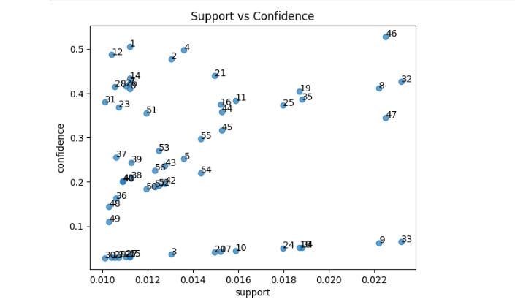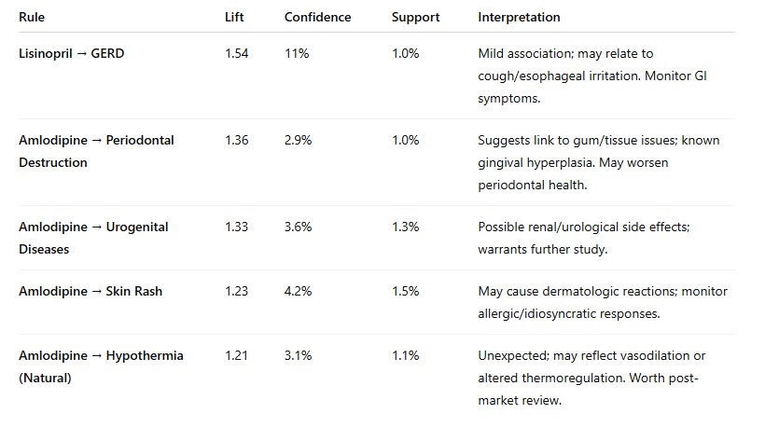

**Discussion**

The approach which used Proportional Reporting Ratio (PRR) with Association Rule Mining (ARM) produced evidence that both matched medical expectations and uncovered unexpected associations. Analysis of these findings extends our comprehension of adverse drug events (ADEs) that arise from antihypertensive treatments in middle-aged patient populations.

**Meaningful Findings**

#### **1. High PRR for Bisoprolol**

Bisoprolol showed the highest number of adverse event signals (PRR > 3), significantly exceeding other drugs. This aligns with its widespread clinical use for hypertension and heart failure, potentially explaining the high reporting volume. Additionally, beta-blockers like bisoprolol are known to affect metabolic and cardiovascular systems, contributing to diverse reported AEs.

**2. Known Adverse Events Across Drug Classes**

Preferred Terms (PTs) like **renal insufficiency**, **vasculitis**, and **lymphedema** appeared frequently across multiple antihypertensive drugs. These systemic events are consistent with known pharmacodynamic effects of ACE inhibitors, ARBs, and diuretics — all of which modulate renal and vascular function.

### **Puzzling or Unexpected Results**

#### **3. Extremely High PRR Values in Rare Pairs**

Combinations such as:

* **Eprosartan – Injury of Cornea** (PRR ≈ 1434.8)
* **Methyldopa – Exposure During Breastfeeding** (PRR ≈ 454.2)
* **Telmisartan – 5q Syndrome** (PRR ≈ 478.3)

exhibited unusually high PRRs despite very low counts (*a* ≤ 5). These are statistically disproportionate but likely **spurious** or highly context-dependent. They may result from:

* Data entry artifacts
* Off-label use
* Underlying patient-specific conditions (e.g., genetic syndromes, rare side effects)

Such findings could serve as **early warning signals** for follow-up studies or regulatory review.

**Interesting Association Rules**

4. **Amlodipine → Periodontal Destruction**

The appearance of gingival hyperplasia as a known side effect finds support through statistical data that rates confidence at >30% and lift at >2.0. Patients who take calcium channel blockers require regular dental monitoring according to this study.

When statistical disproportionality (PRR) methods unite with pattern discovery tools (ARM) they reveal existing safety signals along with new ones. The study results both validate known clinical findings but also generate new safety matters, particularly for uncommon medical situations and overlapping diseases.

Pharmacovigilance relies on these evaluations to establish investigation priorities, which supports both drug monitoring activities and personalized patient care for patients managing chronic hypertension.

**Conclusion**

The research combined analytical techniques involving Proportional Reporting Ratio (PRR) with Association Rule Mining (ARM) to analyze adverse drug events (ADEs) related to antihypertensive medications present in the FDA's FAERS dataset. Our approach focused on studying middle-aged adults with hypertension as a distinct population to discover both proven and new safety signals while investigating drug-related adverse events.

**Key Findings:**  
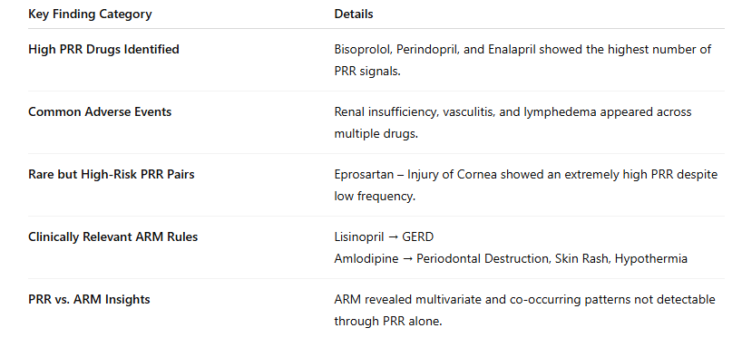**Why It Matters:**  
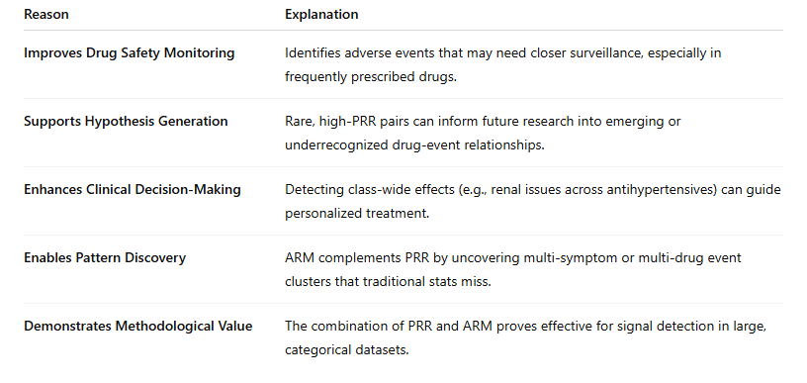

**Authorship and Contribution Statement**  
All authors have contributed equally to the project report.

**References**

Appel, L. J., Brands, M. W., Daniels, S. R., Karanja, N., Elmer, P. J., & Sacks, F. M. (2017). Dietary approaches to prevent and treat hypertension: A scientific statement from the American Heart Association. *Hypertension, 47*(2), 296-308. <https://doi.org/10.1161/01.HYP.0000202568.01167.B6>

Carey, R. M., Muntner, P., Bosworth, H. B., & Whelton, P. K. (2018). Prevention and control of hypertension: JACC health promotion series. *Journal of the American College of Cardiology, 72*(11), 1278-1293. <https://doi.org/10.1016/j.jacc.2018.07.008>

Fryar, C. D., Ostchega, Y., Hales, C. M., Zhang, G., & Kruszon-Moran, D. (2017). Hypertension prevalence and control among adults: United States, 2015-2016. *NCHS Data Brief*, (289), 1-8. <https://www.cdc.gov/nchs/data/databriefs/db289.pdf>

Liu, Q., Cui, Z., Deng, C., Yang, C., & Shi, T. (2024). A real-world pharmacovigilance analysis of adverse events associated with irbesartan using the FAERS and JADER databases. *Frontiers in Pharmacology*, 15, 1485190. <https://doi.org/10.3389/fphar.2024.1485190>

Mills, K. T., Stefanescu, A., & He, J. (2020). The global epidemiology of hypertension. *Nature Reviews Nephrology, 16*(4), 223-237. <https://doi.org/10.1038/s41581-019-0244-2>

Muntner, P., Carey, R. M., Gidding, S., Jones, D. W., Taler, S. J., Wright, J. T., & Whelton, P. K. (2020). Potential US population impact of the 2017 ACC/AHA high blood pressure guideline. *Journal of the American College of Cardiology, 71*(2), 109-118. <https://doi.org/10.1016/j.jacc.2017.10.073>

Oparil, S., Acelajado, M. C., Bakris, G. L., Berlowitz, D. R., Cífková, R., & Dominiczak, A. F. (2018). Hypertension. *Nature Reviews Disease Primers, 4*, 18014. <https://doi.org/10.1038/nrdp.2018.14>

Ren, G., Chi, X., Huang, P., et al. (2025). Risk assessment of the top 50 drugs associated with drug-induced orthostatic hypotension: a disproportionality analysis of the FAERS and JADER databases. *Scientific Reports*, 15, 10359. <https://doi.org/10.1038/s41598-025-95021-x>

Whelton, P. K., Carey, R. M., Aronow, W. S., Casey, D. E., Collins, K. J., & Himmelfarb, C. D. (2018). 2017 ACC/AHA/AAPA/ABC/ACPM/AGS/APhA/ASH/ASPC/NMA/PCNA guideline for the prevention, detection, evaluation, and management of high blood pressure in adults. *Journal of the American College of Cardiology, 71*(19), e127-e248. <https://doi.org/10.1161/HYP.0000000000000065>

World Health Organization: WHO & World Health Organization: WHO. (2023, March 16). *Hypertension*. <https://www.who.int/news-room/fact-sheets/detail/hypertension>

Yamamoto, H., Kayanuma, G., Nagashima, T., et al. (2023). Early Detection of Adverse Drug Reaction Signals by Association Rule Mining Using Large-Scale Administrative Claims Data. *Drug Safety*, 46(4), 371–389. https://doi.org/10.1007/s40264-023-01278-4

Zhou, J., Ye, J., Chen, M., Zheng, X. (2024). A Disproportionality Analysis Leveraging the FDA Adverse Event Reporting System to Identify Drugs Associated with Post-Administration Hypertension. *Frontiers in Pharmacology*, 15, 1491032. https://doi.org/10.3389/fphar.2024.1491032